**План-конспект открытого урока**

**Тощевой Татьяны Валентиновны,**

**учителя английского языка МБУ «Школа №20»**

**В 9 классе по теме «Public Services»**

**в рамках городского «Месячника профориентации»**

**Тема: Public services** (Общественные заведения)

Цель: познакомить учащихся с видами общественных организаций и профессиями, к которым принадлежат люди, которые работают в этих организациях.

Задачи:

обучающие:

- освоить во всех видах речевой деятельности новые лексические единицы по теме «Общественные заведения», «Профессии»

- научиться вести разговор об общественных учреждениях

развивающие:

– развивать навыки во всех видах речевой деятельности;

– развивать познавательные интересы за рамками урока;

воспитательные:

– воспитывать готовность отстаивать свою гражданскую позицию;

– воспитывать культуру поведения через освоение норм этикета

**Ход урока**

1. **Приветствие**

Good morning boys and girls. I’m very glad to see you.

1. **Организационный момент**

How are you?

Are you in a good mood today?

1. **Фон.зарядка**

Let’s train our tongues. Open your WL 6d. Repeat the words after me.

Опрос слов. Тренировка в правильном произнесении слов, словосочетаний.

1. **Введение в тему урока.**

Задачи: мотивация на работу по теме «Общественные заведения»;

Look at the blackboard. There are some pictures of different places, buildings. What we are going to speak about?

* Yes, we are going to speak about “Public services”. Today at the lesson you’ll do a lot of different tasks. Here is the table with your names. For every good answer you’ll get the smile. At the end of the lesson we’ll count them and every of you will get the mark.

1. **Задачи: развитие навыков использования новой лексики в речи.**

Open your books at p.96. Look at the pictures. Read and translate the names of the public services. Have you ever visited library? Have you ever visited post office?

Do you visit bank? **What did you do there? What did you call there for?**

First read and translate the phrases than answer using an example: I went to the post office yesterday to send a parcel to my aunt.

I went (called) to …….. yesterday to……

1. **Упр. 2, с. 96**

Задачи: повторение изученной и введение новой лексики по теме «Общественные заведения, профессии»; развитие навыков её использования в речи; развитие умений монологической речи (описание профессии).

Карточки на доске

Look at the blackboard.

There are some public services and the names of the jobs. Come to the blackboard and match them. Don’t forget to translate the names of the jobs.

Карточки ученикам

Now try to describe the place the job and the qualities which people need to work there.

Look at the example. Read, translate.

I’ll give you the cards, show them to the class, read translate and make your sentences.

**p.96 ex.2 Read the example and translate.**

**Предполагаемый ответ:**

An attendant works at a petrol station. Attendants need to be friendly as they talk to drivers.

A surgeon works in a hospital. Surgeons need to be intelligent and skilful as they do/perform difficult surgeries.

A doctor works in a hospital. Doctors need to be responsible and hardworking as they work many hours and deal with many problems.

A librarian works in a library. Librarians need to be organised as they keep many books and records.

A mayor works in the town hall. Mayors need to be likeable as they are voted in by the people.

A secretary works in the town hall. Secretaries need to be efficient to deal with many tasks.

A police officer works in a police station. Police officers need to be honest as they have a lot of power.

A forensic scientist works in a police station. Forensic scientists need to be patient and efficient as they work in complicated cases.

A detective works in a police station. Detectives need to be hardworking, patient, attentive and efficient as they work many hours and decide

other people’s fates.

A cashier works in a petrol station/railway station/ bank. Cashiers need to be careful and responsible as they work with money.

A postal worker works in a post office. Postal workers need to be responsible to deliver the mail to the right places.

A fire officer works in a fire station. Fire officers need to be strong and skilful and brave to fight fires.

A postman works in a post office. Postmen need to be organized and healthy to walk to houses and deliver mail.

1. **Физ.минутка**

Please put away everything. Let’s have a rest.

Close your eyes

Open your eyes

Look right

Look left

Look at the door

Look at the window

Look up

Look down

1. **Упр. 3, с. 96 (развитие навыков аудирования)**

Задачи: повторение изученных словосочетаний по теме «Общественные заведения»;

развитие социокультурной компетенции (выбор правильного ответа в соответствующей ситуации общения).

Open your books at p.96 ex.3. Listen to the sentences. Make the exchanges. Read the exchanges, translate and decide where each is taken place

Ключи:

1 e 2 a 3 h 4 g 5 c 6 f 7 b 8 d

1 post office – stamps; 2 railway station – tickets, single, return; 3 post office – parcel, scales; 4 library – books, overdue; 5 bank – withdraw some money, account, how much; 6 bank – open an account, fill in a form; 7 railway station – which platform, the 8.30, platform twelve; 8 library – out right now, reserve

1. **Упр. 4, с. 96 (работа в парах)**

Задачи: развитие умений диалогической речи (комбинированный диалог); развитие социокультурных умений.

You’ll work in pairs. I’ll give you the exchanges from the dialogue. You should put them into right order to make the dialogue, read and translate. The other should listen to each other and name the place or public service.

I’ll give you three minutes

Диалог 1

* Good morning. I would like to send this parcel to China, please. How much does it cost?

- Well, we have to know its weight [weit] вес first. Can you put the parcel on the scales[skeilz]весы , please? So, it weighs 3 kg. Is there anything fragile [‘fræʤail] хрупкое inside?

- Oh yes. I’m sending a bottle of perfume to my aunt. So I need some special wrapping paper for that, please.

- OK. No problem, sir. Please, write down the address on the package legibly. And would you like to insure the parcel?

- I would rather not. There is nothing valuable in it. So how much is the postage пересылка?

- That`s 40 dollars for the stamps and for our wrapping and packing services all together.

- Do you accept credit cards?

- Yes, of course.

Диалог 2

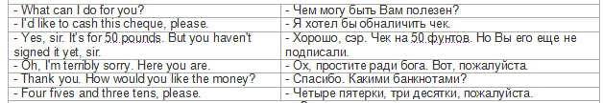

Диалог 3

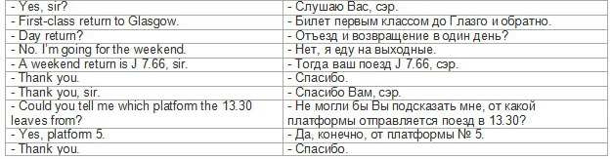

Диалог 4

Viktor: I’d like to get a library card.

Librarian: Do you live in this neighborhood?

V: Yes, I do. I live at 120 Maiden Lane.

L: May I see your driver’s license?

V: Sorry, I don’t have it with me.

L: Do you have any other proof of address?

V: Yes, I do. Here is a letter I received from my bank a week ago. You can see my address.

L: That’s okay. Here’s an application card. Fill in the front application. Please sing [sain] (подписать) your full name

Диалог 5

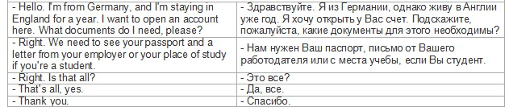

Диалог 6

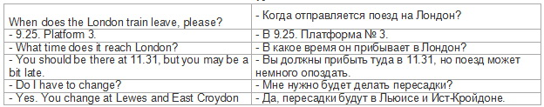

Диалог 7

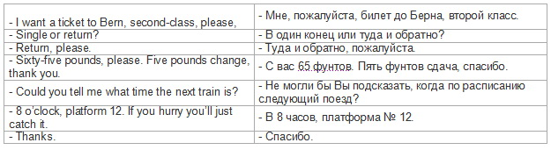

1. **Упр. 5, с. 97**

Задача: развитие умения прогнозировать содержание текста.

Look at ex.5 p.97. Look at the form. Where do you think the dialogue take place?

Ключи:

In a police station.

What are we going to listen to about?

Ключи:

To report an incident or crime. The details of an incident or crime.

Задача: развитие умений аудирования (аудирование с извлечением заданной информации).

Listen to the dialogue and fill in the information

Ключи:

1 Harvey; 2 8475632; 3 a motorbike; 4 black; 5 credit cards; 6 leg

Answer the questions about the dialogue.

* What is the name of witness?
* Where does he live? What is his address?
* What is his telephone number?
* Where did an incident take place?
* Describe the man on motorbike
* What had happened with an old lady?

1. **Развитие монологической речи**

Now imagine that you are Jackie Harvey. Introduce yourself. Speak about your address , telephone number. And describe what you had seen.

Hello my name is….

I live in….

My telephone number is….

Once I went down ….

I saw a…….

Old lady……

1. **Подведение итогов**

At the lesson we did a lot of different tasks

1. **Рефлексия**

Were the tasks difficult for you?

What was the most difficult task for you at the lesson?

What was the easiest task?

What public services did you know about?

What are they for?

Are you tired?

1. **Выставление отметок**

Look at the table with your results. During the lesson you’ve gotten the smiles. And your marks for the lesson are….

1. **H/T p.96 ex.4 (In pairs make up and act out dialogues**)